**CS 120 Web Programming  
Assignment JSON/API: Deliverables**

**JSON Tasks:**

* json.html, json1.html. json2.html, json3,html, songs.json compressed in a zip file and uploaded to canvas

URL for  json.html online (choose github or siteground – not both)

URL:  <https://vattanaeang.github.io/TuftsCS120/Assignment_JSON_API/json.html>

**API Tasks:**

* uses_api.html uploaded to canvas
* URL for uses_api.html online (choose github or siteground – not both)

URL: <https://vattanaeang.github.io/TuftsCS120/Assignment_JSON_API/uses_api.html>

* Postman screenshot – paste below

This API will return geo location of a city

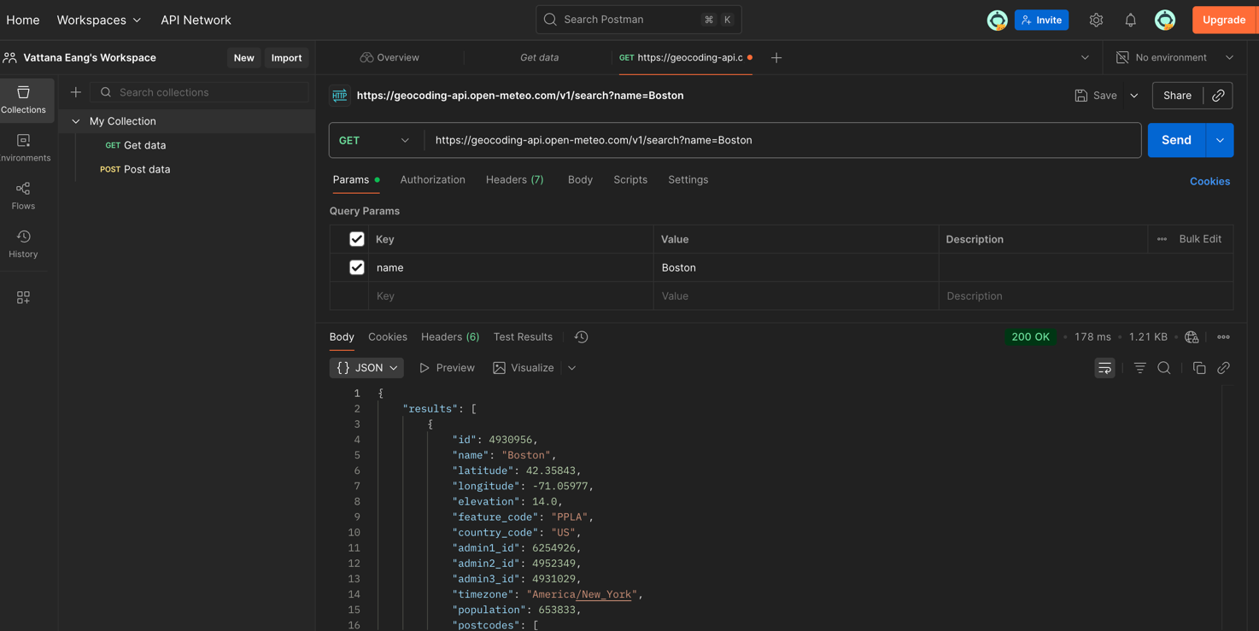

This API returns weather data for a searched location

Describe the API you selected and what it does

**Cite the website that offers the API**

1. <https://open-meteo.com/en/docs/geocoding-api>
2. <https://open-meteo.com/en/docs>

**Describe the options/parameters you used for the API request – i.e., what query info did you need to provide to the API to get your results?**

This 1st API accepts a parameter for the name of the city. The result returns latitude and longitude which then will be used by the next API

The 2nd API below takes in two parameters, latitude and longitude. In uses_api.html, I used temperature and windspeed from current_weather to print. One thing to note, the temperature returned by the API is in degree Celsius. A simple solution was to convert it to Fahrenheit by multiplying the value by 5, then divide by 9, then add 32.

**Identify two applications where this API would be helpful.**

The 1st API can very useful when trying to determine the latitude and longitude position of a city which then can be used to build applications such as weather or navigation related.